KASHIPUR MICHEAL MADHUSUDAN MAHAVIDYALAYA
(PERSONAL PROFILE)
Name: DEBES NASKAR 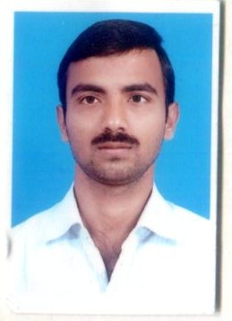
Designation: ASSISTANT PROFESSOR
LDate of Joining: 17.07.2020
e-mail: debesnaskar1@gmail.com

Educational Qualification:
- Graduation: ZOOLOGY
- Post-graduation: M.Sc IN ZOOLOGY
- M.Phil / Ph.D. : NA

State Level / National / International Conferences /Seminars /Workshops /Webinar Attended:
- Paper Presentations in Seminars / Conferences / Webinars
- NO

- Participation in Seminars / Conferences / Training Programmes / Workshop / Webinars
- NATIONAL LEVEL WEBINAR
- STATE LEVEL WEBINAR

List of Research Papers published in National / International Journals / Books / Conference Proceedings with ISBN / ISSN / Impact Factor:
- Books:
- NO
B)Journals:
1. NO
C)Conference Proceedings:
1. NO

Awards and Recognition:
- QUALIFIED CSIR NET 2013(DECEMBER)

Areas of Specialization in Research / Teaching:
- Specialization in Teaching: ENTOMOLOGY

- In Research: NO

Teaching:
- Theory: YES
- Practical:YES
- Excursion / Field Survey: YES

Invited Lecture / Foreign Visit:
1.N.A

Other Academic Activities:

- Board of Studies: NO
- Course Design: NO
- Paper Setter: YES

Administrative Activities:

- Member of Free Ship, Scholarship committee of KMMM

Associated with Learned Bodies / Association / Society / Organization:

1.NO

